**Analysis:**

**1. Analysis of data available based on region.**

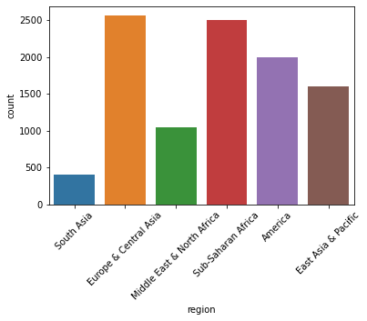

I**n given dataset, More data is from Middle East & North Africa and Middle East & North Africa as compared to other and data of South Asia is the lowest among all regions.**

**2.** **Year wise distribution of data**

2.1 Year vs Fartility

2.2 Year vs life

2.3 Year vs population

2.4 Year vs Child_Mortality

2.5 Year vs GDP

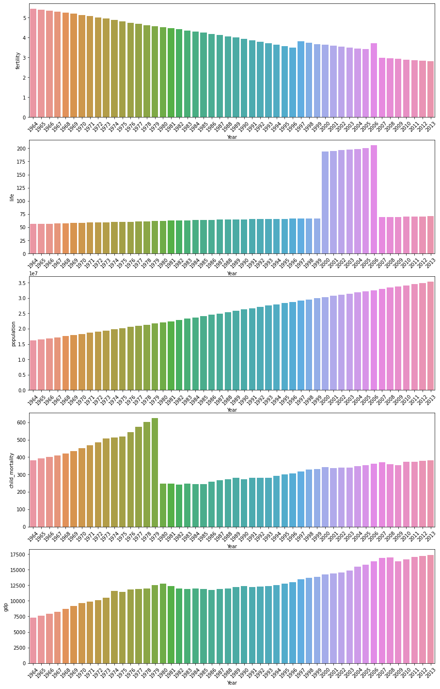

1. **Fertility is decreased continuously (except 1996 May be due to atmospheric change fertility increase)**
2. **Life is almost constant (slightly increasing) (except 2000-2006 the rate of life is quite high)**
3. **Population is increased steadily there is no exception.**
4. **Rate of Child Mortality quite high between 1964-1979(steadily increase). Highest Child mortality in 1978. In 1980, Child mortality drops suddenly 3 times and then slowly and steadily increased.**
5. **GDP increase steadily from 1964-1980. GDP from 1981-1995 is almost constant. After 1996 GDP is increased steadily.**

**3.** **Region wise distribution of data**

2.1 Region vs Fartility

2.2 Region vs life

2.3 Region vs population

2.4 Region vs Child_Mortality

2.5 Region vs GDP

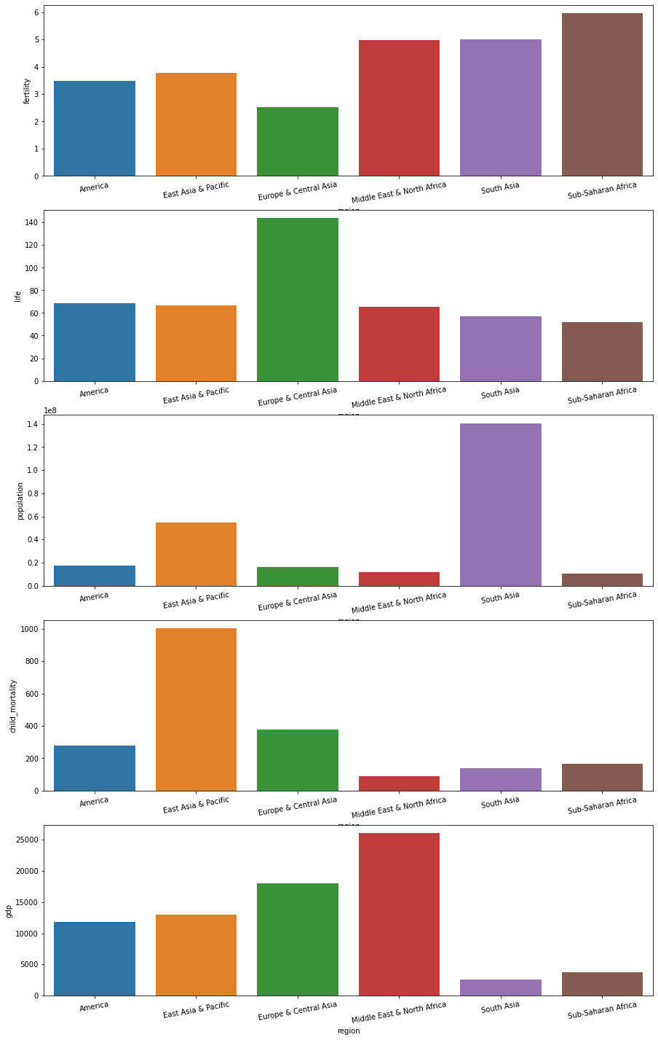

1. **The Most fertile region is Sub-saharan Africa and the least fertile Europe & Central Asia.**
2. **The Life in Europe & Central Asia is quite high as compare to other region.**
3. **Population of South Asia is quite high as compared to other regions.**
4. **Child Mortality of East Asia & Pacific is quite high as compared to other regions.**
5. **Highest GDP is in the Middle East & North Africa and the lowest is in South Asia.**

## **3. Region wise Distribution of data (Finding Outliers)**

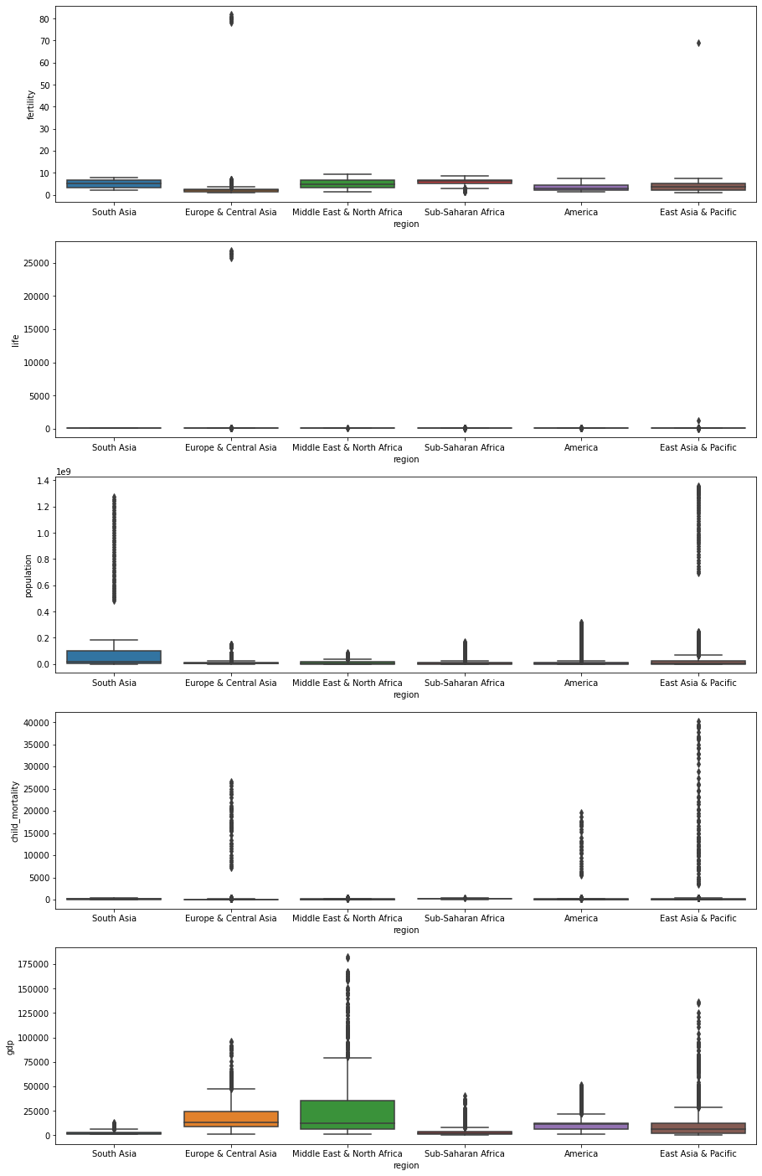

1. **In case of fertility, Europe & Central Asia, Middle East & North Africa and East Asia & Pacific contents outliers.**
2. **In case of life, Europe & Central Asia and East Asia & Pacific contents outliers.**
3. **There are lots of outliers in each region in case of population.**
4. **In case of Child Mortality, Europe & Central Asia, America and East Asia & Pacific contents outliers.**
5. **There are lots of outliers in each region in case of GDP.**

## **4. Country wise EDA(India)**

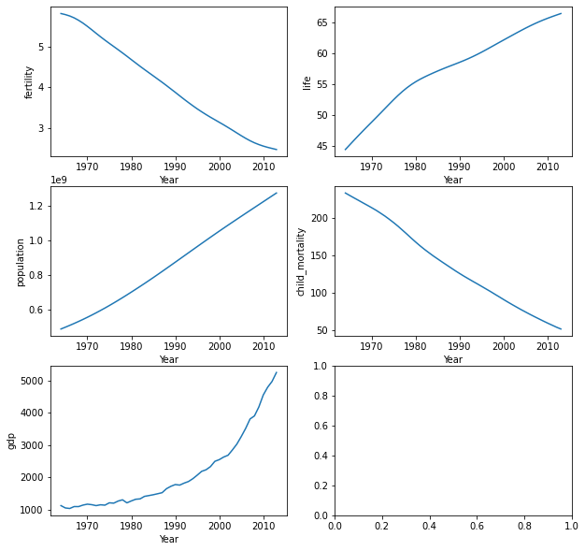

1. **As we see world fertility, In India, the same trend is going on from 1964-2013.**
2. **The Life in India increases steadily.**
3. **There is a steady increase in population.**
4. **Child mortality is steadily decreased.**
5. **Rate of the increase in GDP, not that much from 1964-1990 but GDP increase continuously after 1990.**